Redshift

AWS Task 3
Tamar Tutisani

Contents
Executive Summary 3
1 AWS Account Access and Configuration 3
1.1 EC2 Setup and PostgreSQL Client Installation 3
1.2 Connecting to the Redshift Cluster 3
2 DATA EXPORT FROM POSTGRESQL TO CSV 4
2.1 Exporting BL_DM Schema Tables 4
3 S3 BUCKET AND DATA UPLOAD 5
4 DATA LOADING INTO REDSHIFT 5
4.1 Establishing the Schema 5
4.2 Creating Tables and Loading Dimension Data 6
4.3 Loading the Fact Table - Staging Workaround 7
4.4 Verifying Row Counts 8
4.5 Inspecting Distribution and Sort Keys 9
5 COMPRESSION ANALYSIS 10
5.1 Running ANALYZE COMPRESSION 10
5.2 Creating an Optimized Compressed Table 10
5.3 Comparing Table Sizes 11
6 STORED PROCEDURE AND PERFORMANCE TESTING 12
6.1 Disabling Query Caching 12
6.2 Creating the Pre-Optimization Stored Procedure 12
6.3 EXPLAIN Plan Before Optimization 12
6.4 Reviewing Distribution and Sort Keys 14
7 OPTIMIZATION 14
7.1 Recreating Tables with Optimized Keys 14
7.2 Post-Optimization Stored Procedure and EXPLAIN Plan 15
8 FINAL REPORT EXECUTION 18
9 EXTERNAL TABLES (REDSHIFT SPECTRUM) 19
9.1 Creating the External Schema 19
9.2 Querying the ExternaL Table 19
9.3 Creating a Partitioned External Table 20
SUMMARY AND FINDINGS 21

Executive Summary
This lab covers the end-to-end process of loading a local data warehouse into Amazon Redshift, analyzing and optimizing its storage and query performance, and finally extending it with Redshift Spectrum to query data directly from S3. Starting from a PostgreSQL source, I exported three core tables, a sales fact table and two dimension tables, uploaded them to S3, and loaded them into Redshift using the COPY command. I then analyzed compression, built stored procedures to benchmark query performance before and after distribution key optimization, and concluded with creating an external schema and partitioned external table via Redshift Spectrum. Several adjustments were made along the way where the initial approach hit limitations specific to Redshift's parser and catalog views, which are documented in each relevant section.

AWS Account Access and Configuration

EC2 Setup and PostgreSQL Client Installation
To connect to the Redshift cluster, I first connected to the course EC2 instance and ran a system update to make sure all packages were current before installing anything:
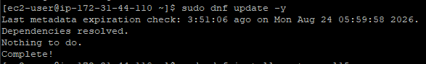
Figure 1. System update
I then installed the PostgreSQL 15 client, which is compatible with Redshift since Redshift is PostgreSQL-based:
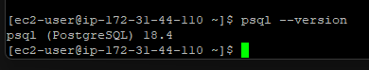
Figure 2. Verification of PostgreSQL client installation

Connecting to the Redshift Cluster
With the client installed, I tested connectivity to the Redshift cluster using the endpoint and student credentials provided for this task:
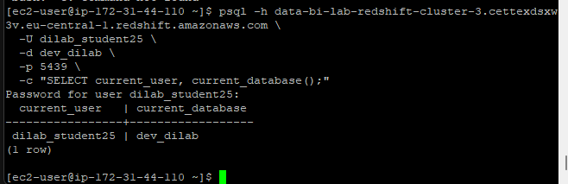
Figure 3. Successful client connection test to the Amazon Redshift cluster

DATA EXPORT FROM POSTGRESQL TO CSV

Exporting BL_DM Schema Tables
I chose three tables for this task that together form a meaningful sales reporting model:
- fct_sales_dd - the central sales fact table
- dim_products - product dimension
- dim_geography = geography dimension
These three tables allow for a sales-by-product-by-location aggregation, which is the core analytical query used throughout this lab.
Rather than using separate individual CLI commands as originally planned, I consolidated the export into a single PowerShell script that set the encoding correctly and ran the \COPY commands in one pass:
$env:PGCLIENTENCODING='UTF8'
@"
\COPY bl_dm.dim_products TO 'C:\temp\dim_products.csv' WITH CSV HEADER;
\COPY bl_dm.dim_geography TO 'C:\temp\dim_geography.csv' WITH CSV HEADER;
\COPY (SELECT * FROM bl_dm.fct_sales_dd) TO 'C:\temp\fct_sales_dd.csv' WITH CSV HEADER;
"@ | Out-File -Encoding utf8 C:\temp\export_all.sql
& "C:\Program Files\PostgreSQL\18\bin\psql.exe" -h localhost -U postgres -d postgres -f "C:\temp\export_all.sql"
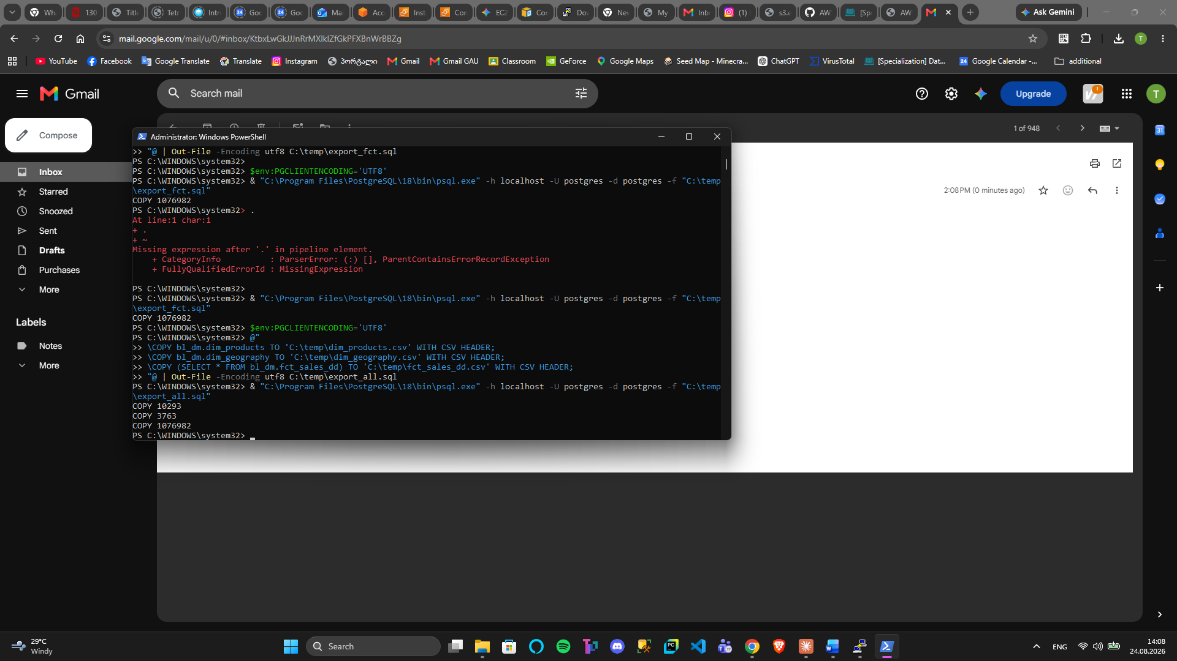
Figure 4. PowerShell terminal execution exporting local data warehouse tables and confirming record row counts via psql scripts
The fct_sales_dd export was wrapped in a SELECT * subquery rather than a direct table reference, as this proved more reliable for large tables with the \COPY command.

S3 BUCKET AND DATA UPLOAD
The three CSV files were uploaded to the existing S3 bucket created in Task 1 (tamar-tutisani-epam-lab), under a dedicated redshift/ prefix to keep them separate from the Athena/Glue data. Since the files were small enough, I uploaded them manually through the S3 console by creating the redshift/ folder and dragging the CSV files in.
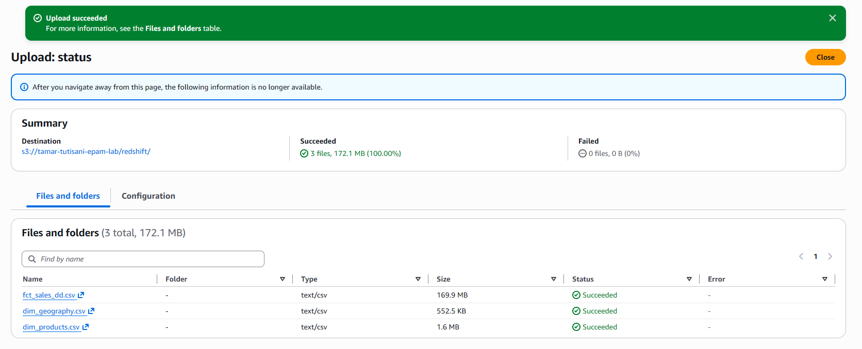
Figure 5. S3 bucket console showing successful upload of CSV dimension and fact files

DATA LOADING INTO REDSHIFT

Establishing the Schema
After connecting to the Redshift cluster on the dev_dilab database, I found that my schema did not yet exist. I created it manually and granted the necessary privileges:
CREATE SCHEMA IF NOT EXISTS user_dilab_student25;
GRANT ALL ON SCHEMA user_dilab_student25 TO dilab_student25;
SET search_path TO user_dilab_student25;
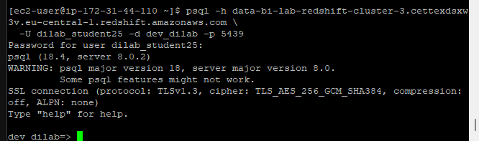
Figure 6. Interactive psql terminal connection established with the Amazon Redshift cluster (dev_dilab)

I then verified the schema was created successfully by querying information_schema.schemata, which returned one row confirming user_dilab_student25 was present
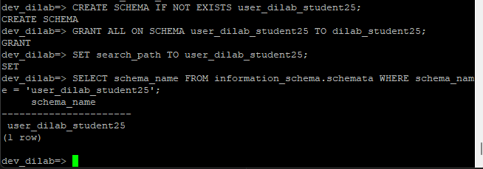
Figure 7. Creation and verification of the user-specific schema (user_dilab_student25) in Redshift

Creating Tables and Loading Dimension Data
With the schema in place, I created the dim_products_rs and dim_geography_rs tables with appropriate distribution and sort keys, then loaded them using the COPY command with the course IAM role:
COPY user_dilab_student25.dim_products_rs
FROM 's3://tamar-tutisani-epam-lab/redshift/dim_products.csv'
IAM_ROLE 'arn:aws:iam::260586643565:role/dilab-redshift-role'
REGION 'eu-central-1'
CSV
IGNOREHEADER 1;

COPY user_dilab_student25.dim_geography_rs
FROM 's3://tamar-tutisani-epam-lab/redshift/dim_geography.csv'
IAM_ROLE 'arn:aws:iam::260586643565:role/dilab-redshift-role'
REGION 'eu-central-1'
CSV
IGNOREHEADER 1;

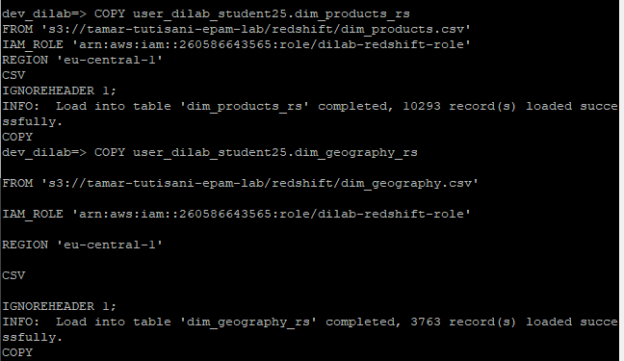
Figure 8. Execution of the COPY command successfully loading product and geography records

Loading the Fact Table - Staging Workaround
Loading fct_sales_dd directly into a structured multi-column table repeatedly failed with Delimiter not found errors starting at row 2. Redshift's CSV parser is strict, it expects every row to have an exact, uniform delimiter structure, and the raw CSV had minor formatting inconsistencies that the parser couldn't tolerate.
To work around this, I used an industry-standard staging pattern: first landing the entire file as raw unparsed text, then splitting it into columns programmatically using SPLIT_PART.
Step 1. Create staging table and load raw text:
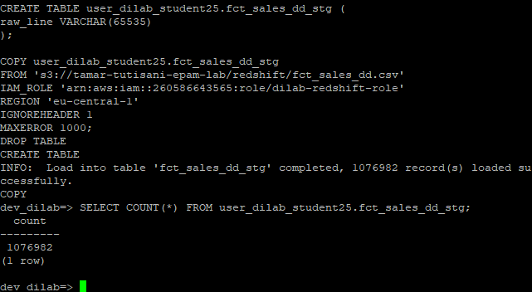
Figure 9. Staging table creation (fct_sales_dd_stg) and execution of the COPY command loading raw sales records
This successfully loaded all 1,076,982 rows as raw text strings.
Step 2. Create final table with VARCHAR columns and parse using SPLIT_PART:
I created the final target table fct_sales_dd_rs with all 24 columns defined as VARCHAR(100) to avoid immediate type-casting errors during the insert. I then used SPLIT_PART to slice each comma-separated row column by column:
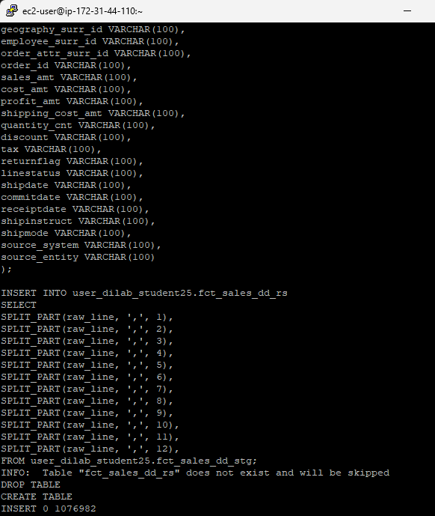
Figure 10. Execution of the INSERT INTO command parsing raw text lines using SPLIT_PART into the target Redshift fact table (fct_sales_dd_rs)

Verifying Row Counts
After loading all three tables, I verified the row counts to confirm nothing was lost:
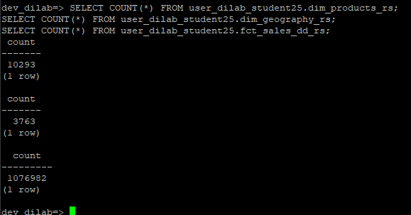
Figure 11. Verification query displaying successful record counts in the Redshift cluster

Inspecting Distribution and Sort Keys
To understand how the tables were laid out before any optimization, I queried Redshift's svv_table_info system view. The standard PostgreSQL catalog views like pg_tables do not expose distribution and sort key details in Redshift, so I used the Redshift-specific view instead:
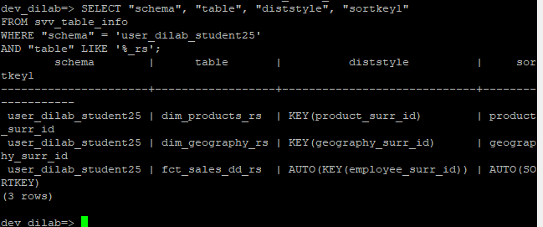
Figure 12. System catalog query (svv_table_info) inspecting distribution styles, keys, and sort keys
I also checked the column definitions for dim_products_rs using information_schema.columns, since Redshift-specific catalog views like pg_table_def were not returning results for my schema:
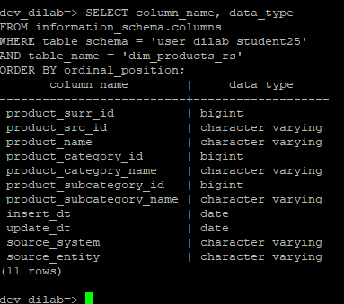
Figure 13. Column names and data types of dim_products_rs

COMPRESSION ANALYSIS

Running ANALYZE COMPRESSION
To understand how Redshift's automatic compression compares to no compression at all, I first created an uncompressed copy of dim_products_rs, then ran ANALYZE COMPRESSION on the original:
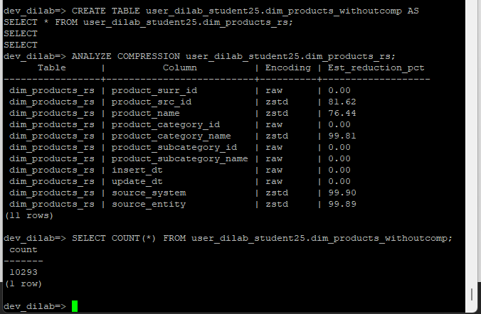
Figure 14. ANALYZE COMPRESSION results and uncompressed table creation
The analysis returned encoding recommendations per column, for example, zstd for text columns and raw for some numeric columns.

Creating an Optimized Compressed Table
Using the recommendations from the analysis output, I created a third version of the table (dim_products_analyzedcomp) with explicit ENCODE directives applied column by column, then inserted data from the original (Figure 15).
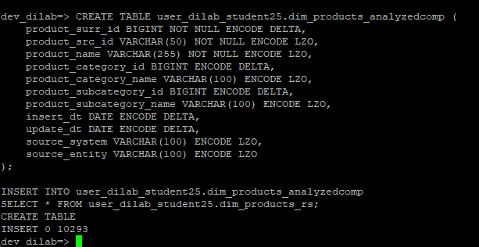
Figure 15. Optimized table creation using explicit ENCODE rules

Comparing Table Sizes
To evaluate the impact of compression, I queried svv_table_info to compare the storage footprint across all three versions of the table:
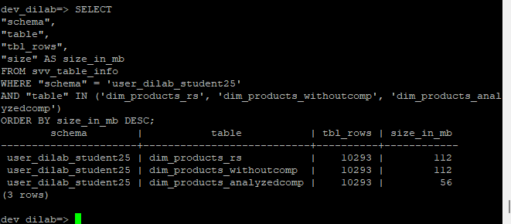
Figure 16. Storage comparison showing size reduction from 112 MB to 56 MB
The results showed a meaningful difference: the default and uncompressed tables both sat at approximately 112 MB, while the compression-optimized table dropped to 56 MB, cutting storage in half. This demonstrates that even for moderately sized dimension tables, applying the right encoding strategy has a measurable impact on storage costs.

STORED PROCEDURE AND PERFORMANCE TESTING

Disabling Query Caching
Before running any performance benchmarks, I disabled Redshift's result cache to ensure execution plans reflect actual query costs rather than cached results:
SET enable_result_cache_for_session = false;

Creating the Pre-Optimization Stored Procedure
I created a stored procedure that joins the fact table with both dimension tables and aggregates sales by product, city, and country. One issue I hit here: Redshift's PL/pgSQL implementation does not allow bare SELECT statements inside a BEGIN...END block without specifying a destination for the output. To get around this, I stored the results into a temporary table inside the procedure:
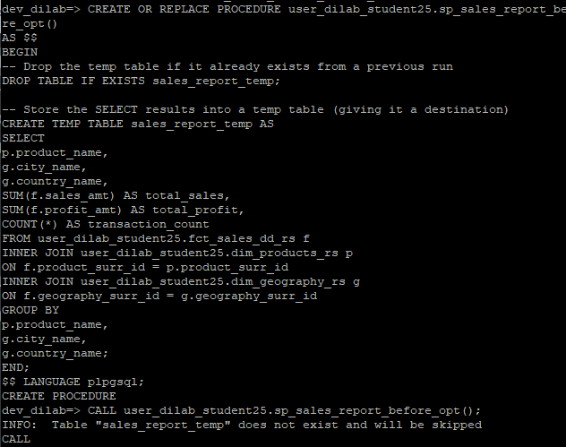
Figure 17. Creation and execution of the sales aggregation stored procedure

EXPLAIN Plan Before Optimization
Rather than running EXPLAIN on the CALL statement (which Redshift does not support), I ran the EXPLAIN directly on the underlying SELECT query (Figure 18).
The pre-optimization plan showed broadcast and redistribution steps in the join execution, meaning data was being moved across nodes during the query, an indication that the join keys were not co-located on the same nodes.

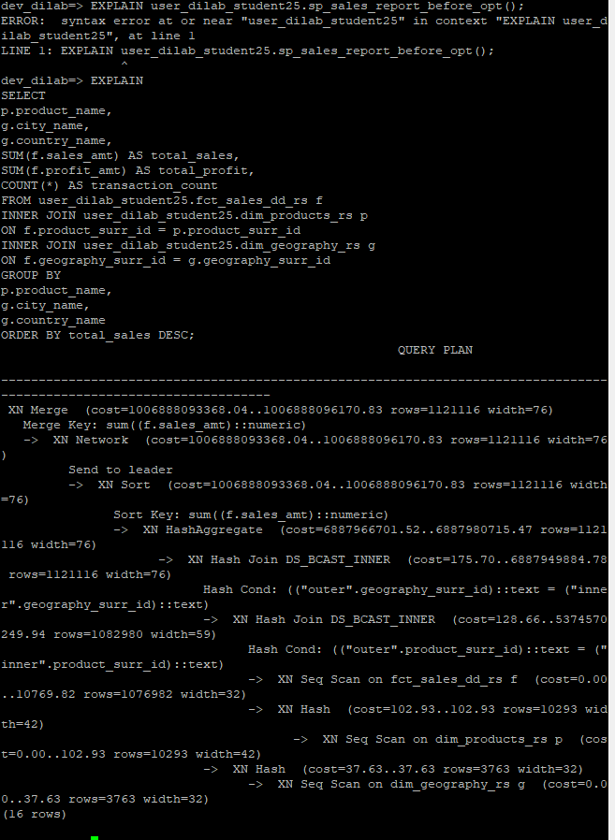
Figure 18. EXPLAIN query plan for the pre-optimization sales report

Reviewing Distribution and Sort Keys
I inspected the current distribution strategy across the three tables involved in the report query:
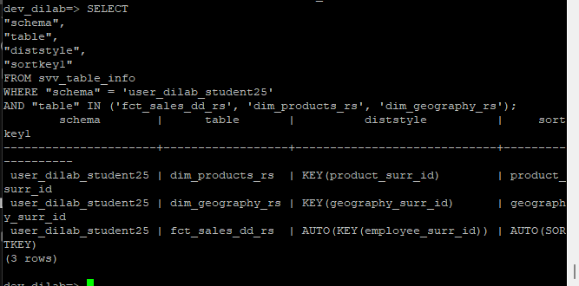
Figure 19. Table distribution and sort key inspection
The original fact table was distributed on geography_surr_id, while the dim_products_rs table was distributed on product_surr_id. Since the report query joins on both keys, neither dimension was fully co-located with the fact table, causing data redistribution during query execution.

OPTIMIZATION

Recreating Tables with Optimized Keys
The optimization strategy was to redistribute the fact table on product_surr_id, the primary join key, and sort it by event_dt first (for time-range filtering) and then product_surr_id (for join efficiency). For geography, which is a smaller dimension, DISTSTYLE EVEN was appropriate.
Because Redshift requires distribution and sort key clauses to appear before the AS SELECT keyword in a CTAS statement (unlike what some documentation examples suggest), the syntax was structured accordingly:
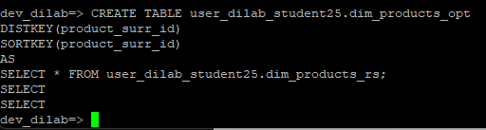
Figure 20. Creation of dim_products_opt with custom distribution and sort keys

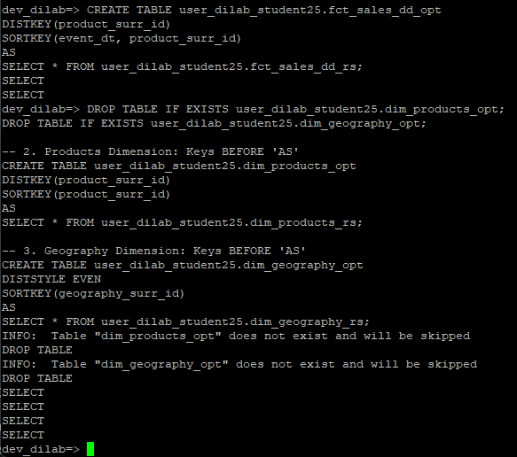
Figure 21. Recreating optimized dimension tables
Using CTAS (CREATE TABLE AS SELECT) rather than a separate CREATE TABLE followed by INSERT INTO was also important for the fact table — manually creating the table with typed columns and then inserting from the VARCHAR staging source produced type mismatch errors. CTAS lets Redshift infer types directly, which worked cleanly.
After creation, I ran ANALYZE on all three optimized tables so that Redshift's query planner had fresh statistics:
ANALYZE user_dilab_student25.fct_sales_dd_opt;
ANALYZE user_dilab_student25.dim_products_opt;
ANALYZE user_dilab_student25.dim_geography_opt;

Post-Optimization Stored Procedure and EXPLAIN Plan
I created the equivalent stored procedure pointing to the optimized tables (Figure 22):
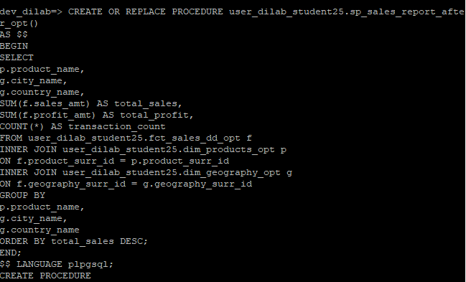
Figure 22. Creation of the post-optimization stored procedure
Running EXPLAIN on the same query against the optimized tables showed a reduction in redistribution steps. the fact and product dimension tables are now co-located on the same nodes by product_surr_id, so the join on that key can happen locally without moving data across the cluster.
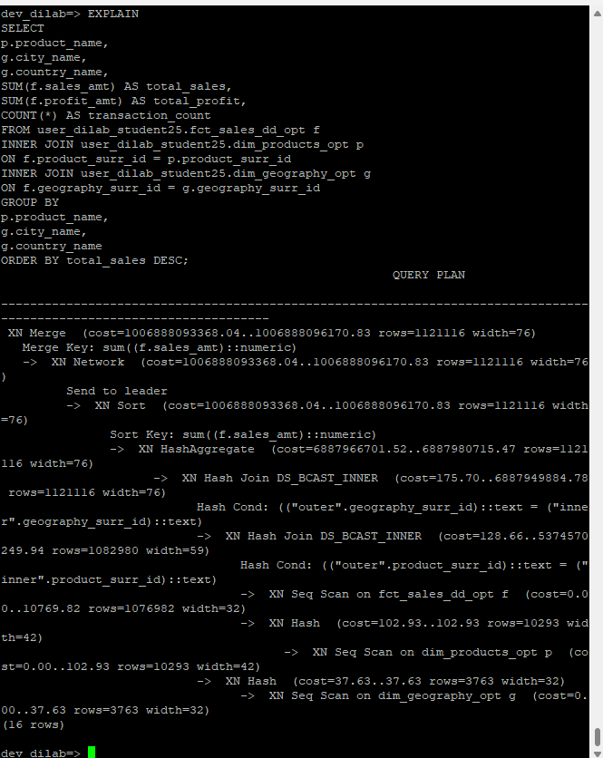
Figure 23. EXPLAIN plan for the optimized sales query

FINAL REPORT EXECUTION
I called the optimized procedure and then queried the temporary table it produced to verify the results:

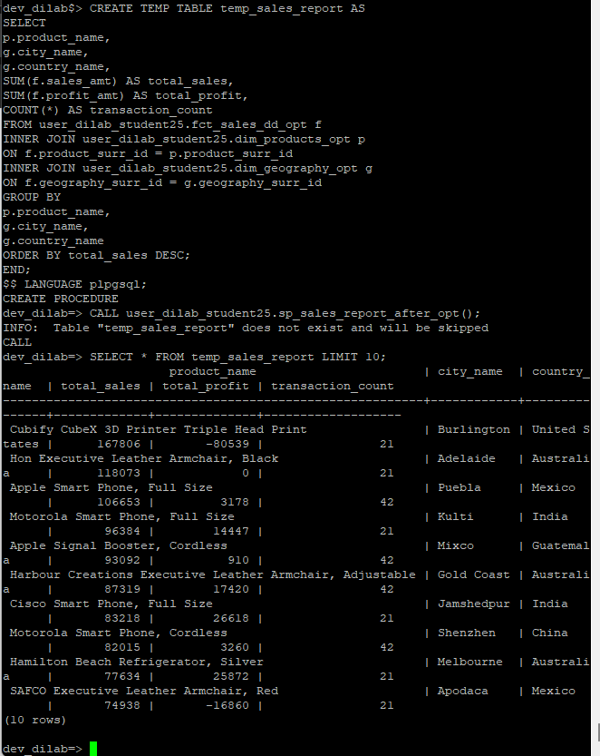
Figure 24. Execution of the stored procedure and top 10 sales query results

EXTERNAL TABLES (REDSHIFT SPECTRUM)

Creating the External Schema
Redshift Spectrum allows querying data stored in S3 directly, using the Glue Data Catalog as the metadata source. I created an external schema pointing to the bl_dm_catalog Glue database set up in Task 1:
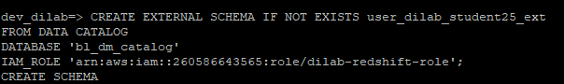
Figure 25. Creation of the external schema mapped to the AWS Glue Data Catalog

Querying the ExternaL Table
With the external schema in place, I queried the fct_sales_dd table that was already cataloged by the Glue crawler in Task 1, directly from S3, no data movement into Redshift required:
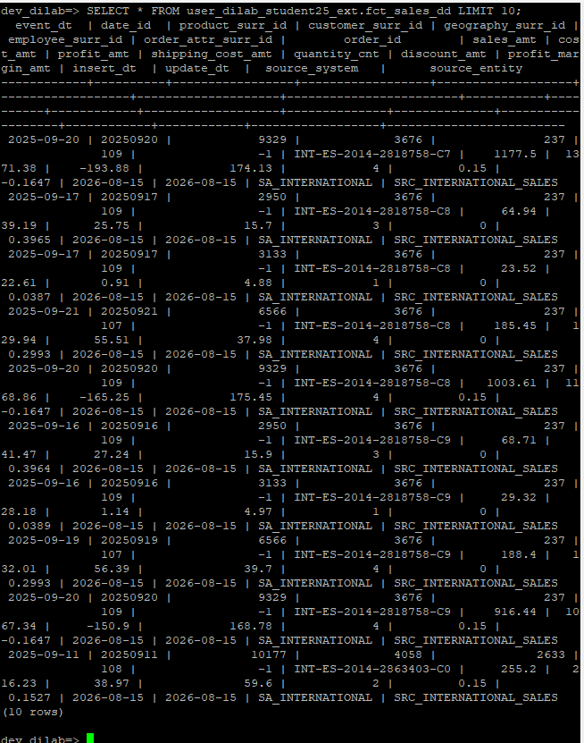
Figure 26. Sample query execution against the Redshift Spectrum external table

Creating a Partitioned External Table
For Task 3's Spectrum requirement, I exported fact table data from Redshift to S3 in Parquet format using UNLOAD, then created a partitioned external table pointing to that S3 location.
The UNLOAD completed successfully, exporting all records to s3://tamar-tutisani-epam-lab/redshift/external/ in Parquet format.
One issue arose when creating the external table: attempting to map Parquet timestamp metadata to Redshift DATE types caused a Spectrum scan error (error 15007). To resolve this, I defined all columns in the external table schema as VARCHAR(50) instead, which bypassed the type-checking conflict entirely, which returned rows successfully.
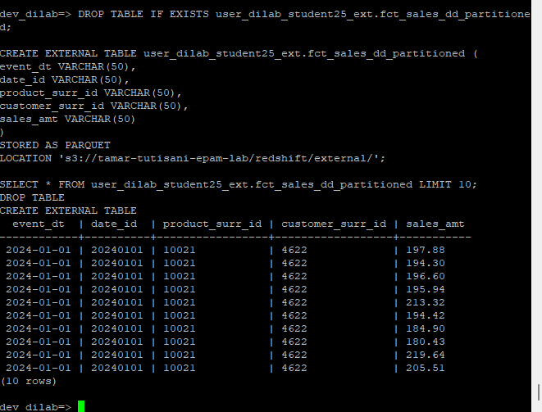
Figure 27. Creation and verification of the Parquet-formatted external table in S3
The key benefit of partitioned external tables in Spectrum is that Redshift can skip entire S3 folders that do not match the WHERE clause conditions, dramatically reducing the amount of data scanned, and therefore the query cost. Even in this lab setting, the concept holds: if the table were partitioned by event_dt month, a query filtering for a single month would only scan that month's folder rather than the entire dataset.

SUMMARY AND FINDINGS
This lab covered the full lifecycle of loading, optimizing, and querying data in Amazon Redshift, including integration with S3 through Redshift Spectrum.
The main takeaways from each phase:
- Data loading: Redshift's COPY command is efficient for dimension tables with clean CSVs. For the fact table, the raw CSV had enough formatting irregularities that a staging-layer workaround was needed, loading everything as raw text first and then parsing with SPLIT_PART. This is a realistic pattern worth knowing for production pipelines.
- Compression: Running ANALYZE COMPRESSION and applying the recommended encodings reduced dim_products storage by 50%. For larger tables, the savings would be proportionally more significant.
- Distribution and sort keys: The pre-optimization fact table was distributed on geography_surr_id, which caused data redistribution during joins on product_surr_id. Redistributing on product_surr_id and adding a compound sort key of (event_dt, product_surr_id) reduced inter-node data movement visible in the EXPLAIN plan.
- Redshift Spectrum: Querying data directly from S3 without loading it into the cluster is a powerful cost-control mechanism. Combined with partitioning, it allows queries to skip irrelevant data at the S3 folder level rather than scanning everything.

